

SALES REPORT GENERATOR

PROJECT REPORT

Submitted by

HARI KRISHNAN GS
(E0124053)
JAI SANTHOSH R
(E0124055)
JEEVA PRIYAN S
(E0124056)
SRI HARI N
(E0124096)

in partial fulfillment for the award of the degree of
BACHELOR OF TECHNOLOGY
IN
COMPUTER SCIENCE & ENGINEERING

SRI RAMACHANDRA INSTITUTE OF HIGHER EDUCATION AND RESEARCH, CHENNAI
NOVEMBER, 2025



BONAFIDE CERTIFICATE

Certified to be the bonafide record of the work done by HARI KRISHNAN GS - E0124053, JAI SANTHOSH R – E0124055, JEEVA PRIYAN - E0124056, SRI HARI – E0124096 of Semester III, Second Year B.Tech Degree course in Sri Ramachandra Faculty of Engineering and Technology, of Computer Science and Engineering Department in the CSE23CL203 Hands on Python Laboratory during the academic year 2025-2026.

DR.R. BHUVANYA, Faculty_Incharge
Assistant Professor,
Sri Ramachandra Faculty of Engineering and Technology,
Sri Ramachandra Institute of Higher Education and Research, Porur, Chennai,
Tamil Nadu.

Submitted for the Hands on Python Laboratory project presentation held at Sri Ramachandra Faculty of Engineering and Technology on :

Internal Examiner External Examiner

TABLE OF CONTENTS

CHAPTER NO. TITLE PAGE NO.
- INTRODUCTION 4
- OBJECTIVES 7
- TECHNIQUES USED 9
- IMPLEMENTATION 12
- RESULTS 18
- CONCLUSIONS AND 24
REFERENCES 28

CHAPTER 1 INTRODUCTION

In the modern era of digital transformation, organizations across all sectors generate vast quantities of operational and transactional data. Among these, sales data is one of the most crucial, as it directly reflects business performance, customer demand, revenue trends, and inventory movement. Sales reports serve as essential documents that summarize these data patterns and support managers, administrators, and decision-makers in evaluating progress, identifying issues, and planning future strategies. However, despite its importance, sales reporting is still widely performed through manual processes, especially in small and medium-sized enterprises (SMEs). These manual processes often involve gathering data from Excel sheets or handwritten logs, performing calculations manually, creating charts using spreadsheet tools, and formatting Word documents. This workflow is tedious, time-consuming, error-prone, and inconsistent, particularly when reports must be generated frequently.

As businesses expand and handle increasingly large volumes of sales data, the limitations of manual reporting become more prominent. Formatting inconsistencies, accidental calculation errors, misaligned tables, missing records, and delays in report submission can significantly affect an organization’s ability to react quickly to market conditions. Moreover, storing past reports for audit or analysis purposes becomes challenging without a structured digital system. To address these shortcomings, there is a growing need for automated, reliable, and user-friendly systems that transform raw data into meaningful and well-formatted reports with little to no manual effort.

Python, with its rich ecosystem of data processing and automation libraries, provides a powerful platform for building such solutions. Libraries like pandas allow efficient manipulation of large datasets, matplotlib enables high-quality chart generation, python-docx supports automated creation of Word documents, and reportlab allows PDF report generation. Coupled with MySQL for structured data storage and tkinter for building graphical user interfaces (GUIs), Python becomes a complete environment capable of delivering end-to-end automated reporting tools. The integration of these technologies forms the foundation of this project: Sales Report Generator using Python GUI & MySQL.
The primary aim of this system is to simplify and automate the sales reporting process. Users can upload their data in CSV or Excel formats, and the system automatically detects column headers, cleans the data, calculates total sales, generates summary tables, and produces professionally formatted reports in either Word (.docx) or PDF (.pdf) format. The user is also given the choice to include or skip sales charts based on preference. Furthermore, all processed records are stored in a MySQL database, providing long-term data persistence for future analysis, auditing, or integration into larger business dashboards. This eliminates the risk of losing historical data and ensures that organizations can access their entire reporting history in a structured format.

One of the core motivations behind this project is accessibility. Most automated reporting tools currently available in the market either require expensive subscriptions or demand advanced technical skills to operate. This places a burden on small businesses, academic institutions, and non-technical users who need reporting tools but lack resources. The proposed system overcomes these limitations by offering a clean, minimal, and intuitive GUI that guides users step-by-step through the reporting process. With just a few clicks, even users with no programming or analytical knowledge can generate complete reports—making the system highly usable and efficient.

From a technical standpoint, the system also highlights the importance of data validation and standardization. Sales files often come with inconsistent column names such as “desc”, “description”, “item”, “Product Name”, or “Goods Description”. The system automatically maps these various forms to standard labels like “Product”, “Units Sold”, or “Price”, ensuring uniformity in processing. Additionally, error-handling mechanisms detect missing columns, invalid data types, blank rows, and incorrect file formats, preventing system crashes or inaccurate outputs. This ensures that the generated reports are not only fast but also reliable and accurate.

The significance of this project extends beyond automation alone. It demonstrates how open-source programming, when designed with usability and practicality in mind, can replace expensive commercial solutions. It encourages the adoption of lightweight desktop tools that can meaningfully support businesses in their digital transformation journey. The modular design also ensures that future enhancements—such as automated email delivery, multi-user support, advanced analytics, or cloud integration—can be added without reworking the entire system.

In summary, this project addresses a real and growing need for efficient sales reporting tools. By combining Python’s data-processing capabilities with a user-friendly GUI and a robust database backend, it provides a complete and scalable solution suitable for businesses, educational institutions, and individuals alike. The following chapters of this report elaborate on the system design, implementation, testing, and results, demonstrating how the developed tool enhances accuracy, reduces effort, and improves the overall reporting workflow.
CHAPTER 2
OBJECTIVES

The primary objective of this project is to design and develop an automated Sales Report Generator that simplifies the process of transforming raw sales data into professionally formatted reports. The system aims to eliminate the challenges of manual reporting by providing fast, accurate, and user-friendly automation. The detailed objectives of the study are as follows:
Primary Objectives
- To automate the process of generating sales reports from CSV and Excel input files, thereby reducing manual workload and human error.
- To develop a simple and intuitive GUI using tkinter that enables non-technical users to generate reports without requiring programming knowledge.
- To automatically process, clean, and standardize input data using pandas, including column mapping, missing value handling, and numeric type conversion.
- To generate well-formatted Word (.docx) and PDF (.pdf) reports using python-docx and reportlab, ensuring professional presentation quality.
- To incorporate optional sales chart generation using matplotlib to provide visual insights into product performance.
- To store all processed sales data into a MySQL database, enabling historical tracking, audits, and long-term analytics.
Secondary Objectives
- To ensure robust error handling and data validation so that the system can manage inconsistent or messy input files without crashing.
- To support auto-mapping of varying column names (e.g., "desc", "product name", "goods") to ensure compatibility with multiple input formats.
- To minimize user interaction and maximize automation, requiring only file selection and a few simple option choices.
- To create a modular, scalable architecture that allows for easy upgrades such as cloud integration, monthly report scheduling, or dashboard extensions.
Long-Term or Extended Objectives
- To encourage the adoption of low-cost open-source automation tools among SMEs, educational institutions, and small business owners.
- To demonstrate the potential of Python as a practical solution for real-world data processing, report automation, and business workflows.
- To provide a foundation for future enhancements, including automatic emailing of reports, user authentication, multi-user support, and real-time analytics dashboards.
- To reduce dependence on expensive commercial reporting tools by offering a fully functional, locally executable alternative.

CHAPTER 3 TECHNIQUES USED

The development of the Sales Report Generator incorporates various software engineering, data processing, and automation techniques to ensure efficient performance, ease of use, and reliability. The major techniques used in the implementation of the system are as follows:
1. Data Cleaning and Pre-processing
- Used pandas to remove null values, correct data types, and convert inconsistent numeric fields.
- Implemented auto-detection of header rows in Excel sheets using openpyxl to handle messy or poorly formatted files.
- Applied column normalization (lowercasing, trimming spaces, replacing unusual names with standard names).
- Used type coercion to safely convert text-based numbers into integers/floats.
2. Column Auto-Mapping Technique
- Applied keyword-based mapping to identify relevant columns such as Product, Units Sold, and Rate even if they appear under different names like:
  - “description”, “item”, “goods” → Product
  - “qty”, “rec qty”, “quantity”, “nos” → Units Sold
  - “rate”, “price”, “cost” → Unit Price ($)
- Ensured the system remains compatible with multiple data sources.
3. Aggregation and Summary Computation
- Used pandas’ groupby and aggregation functions to compute:
  - Total Units Sold per product
  - Total Sales
- Implemented vectorized operations to maximize speed and reduce compute time even for large datasets.
4. Automated Report Generation Technique
- Used python-docx to automatically create Word documents with:
  - Structured tables
  - Titles and headings
  - Auto-adjusted column widths
  - Embedded images (charts)
- Used ReportLab to dynamically create PDF reports with:
  - Precise text placement
  - Multi-page support
  - Embedded chart images
5. Data Visualization Technique
- Used matplotlib to generate charts that visually represent:
  - Highest-selling products
  - Total revenue distribution
- Applied bar charts with customized formatting for clarity and readability.
- Saved charts temporarily to embed in Word/PDF reports.
6. GUI Development Technique
- Implemented a Graphical User Interface (GUI) using tkinter.
- Used:
  - File dialogs for selecting input files
  - Radio buttons for selecting export format (Word/PDF)
  - Checkboxes for optional chart inclusion
  - Auto-close behavior after successful generation
- Focused on maintaining a simple, clean layout for non-technical users.
7. Database Storage Technique
- Used MySQL Connector to store processed data into a relational database.
- Implemented:
  - Table creation using CREATE TABLE IF NOT EXISTS
  - Safe record insertion using parameterized queries
  - Date normalization before insertion
- Ensured persistent storage for future analytics and audits.
8. Error Handling and Validation Techniques
- Used try–except blocks throughout the system to avoid crashes.
- Displayed clear GUI error messages for:
  - Missing columns
  - Invalid file formats
  - MySQL connection failures
- Ensured robustness even when files contain unexpected or messy data.
9. Modular Programming Technique
- Divided the system into multiple reusable modules such as:
  - Data Loader
  - Header Mapper
  - Summary Generator
  - Report Writer
  - Chart Generator
  - Database Logger
  - GUI Engine
- Improved readability, maintainability, and future scalability.
10. File Handling Technique
- Used Python’s built-in I/O handling to:
  - Save reports with timestamps
  - Manage temporary chart images
  - Handle file paths consistently across OS platforms
- Ensured clean deletion of temporary files after embedding.

CHAPTER 4 IMPLEMENTATION

The implementation of the Sales Report Generator integrates multiple Python libraries, GUI components, data-processing functions, and database routines into a unified and user-friendly system. This chapter describes the practical execution of the proposed design, including workflow structure, module development, program logic, user interface construction, and database integration. The implementation focuses on creating a scalable, robust, and easy-to-use automation tool capable of generating formatted sales reports in both Word and PDF formats.

4.1 Overview of Implementation
The system was implemented using an incremental development approach, beginning with backend processing, followed by document generation, and then the integration of the GUI and MySQL database. This stepwise refinement allowed testing at every stage, ensuring reliability and reducing debugging effort. The final application consists of four major layers:
- GUI Layer – Built using tkinter to enable simple user interactions.
- Data Processing Layer – Utilizes pandas for cleansing, mapping, and summarizing data.
- Report Generation Layer – Employs python-docx and reportlab to create Word and PDF outputs.
- Database Layer – Stores processed rows in MySQL for future retrieval.
Each component works together seamlessly, resulting in an automated reporting system that performs consistently across various file formats and input structures.

4.2 Programming Workflow
The entire process executed by the application can be broken down into the following main stages:
1. File Input Stage
The user begins by selecting a file (.csv or .xlsx). A file dialog is implemented using tkinter’s askopenfilename() function. The selected path is passed to the data loader function for validation and processing.
2. Data Loading and Header Detection
Many real-world sales sheets contain extra empty rows, misaligned headers, and inconsistent formatting. To handle this, the system uses two mechanisms:
- Header Row Detection
A scanning technique using openpyxl searches the first 20 rows of Excel sheets to automatically identify the actual header row.
- Column Normalization
All column names are converted to lowercase, stripped of whitespace, and standardized to minimize variations.
This ensures compatibility with input files from various vendors or branches.
3. Column Auto-Mapping
Since datasets may use different names for the same field (“description”, “item name”, “goods description”), a keyword-based column mapping system was implemented.
For example:
Detected Column Word | Mapped To
desc, description, item, goods | Product
qty, rec qty, nos, quantity | Units Sold
rate, price, cost | Unit Price ($)

This step guarantees smooth data processing even when input files are inconsistent.
4. Data Cleaning & Transformation
Once mapping is complete, the system performs:
- Conversion of numeric columns using pd.to_numeric(errors='coerce')
- Removal of invalid rows
- Calculation of Total Sales ($) if missing
- Conversion of dates using pd.to_datetime()
These operations ensure accurate calculations and error-free report generation.
5. Summary Generation
A summary is created using pandas:
summary = df.groupby("Product", as_index=False).agg({
"Units Sold": "sum",
"Total Sales ($)": "sum"
})
The summary is sorted in descending order of revenue and truncated to the top 10 products for visibility in reports.

4.3 Report Generation
4.3.1 Word Report Generation
Word reports are generated using the python-docx library.
Steps:
- Add report title and date
- Create summary table
- Insert bar chart (if selected by user)
- Save output with filename sales_report_DD_MMM_YYYY.docx
Tables use the “Table Grid” style for clarity. Charts are embedded as PNG images.
4.3.2 PDF Report Generation
PDF reports are generated using ReportLab.
- Header and subheading placed manually using coordinate system
- Table rows written sequentially
- Automatic page-break handling
- Chart image embedded on a new page
PDF generation ensures compatibility with systems where Word is not installed.

4.4 Data Visualization – Chart Module
Charts are generated using matplotlib, using a horizontal or vertical bar graph depending on data size.
Key features:
- Top 10 products selected for readability
- Tight layout applied to avoid text cut-off
- Temporary PNG stored and deleted after embedding
Charts allow users to interpret sales performance visually.

4.5 MySQL Database Integration
A relational database is used for long-term storage of processed sales data. The system:
- Establishes connection using mysql.connector.connect()
- Creates the table sales_log if not already present
- Inserts rows using parameterized queries
- Converts pandas timestamps to Python date objects
- Commits every transaction before closing connection
This ensures that every processed dataset is safely archived.

4.6 Graphical User Interface (GUI)
The GUI is designed using tkinter for simplicity and clarity.
GUI Features
- File selector (Browse button)
- Checkbox for “Include Chart”
- Radio buttons for selecting export type (Word or PDF)
- Generate button (green)
- Success message followed by automatic closure
The GUI follows a minimalistic approach to ensure that non-technical users can operate it effortlessly.

4.7 Error Handling Strategies
To ensure robustness, several techniques were used:
- Try–except blocks around file reading and MySQL operations
- User-friendly error messages via messagebox.showerror()
- Graceful fallback when MySQL connection fails
- Logging of unexpected errors in console
This allows the system to run smoothly even with poor input quality.

4.8 Testing and Validation
Datasets Used
- Small (50–100 rows)
- Medium (500–1000 rows)
- Large (5000–10,000 rows)
Test Platforms
- Windows 10/11
- macOS Ventura
- Ubuntu 20.04
Evaluated Aspects
- Data loading accuracy
- Column detection
- Word/PDF formatting consistency
- Chart embedding quality
- Database insertion accuracy
- Performance and speed
All modules performed reliably, with average report generation times between 2–8 seconds depending on dataset size.

4.9 Summary
The implementation successfully integrates file handling, data processing, visualization, report generation, and database storage into a cohesive system. The modular structure ensures maintainability and easy future enhancement. With its combination of automation, accuracy, and usability, the system serves as an effective alternative to manual reporting workflows.

CHAPTER 5
RESULTS

This chapter presents the results obtained from implementing and testing the Sales Report Generator. The outcomes highlight the system’s performance, accuracy, usability, and ability to handle diverse datasets. The discussion also compares the automated approach with conventional manual reporting, demonstrating the effectiveness and reliability of the developed application.

5.1 Overview of Output Generated
The system accepts sales data in CSV or Excel format, processes and validates the information, and generates a structured report in either Word (.docx) or PDF (.pdf) format. The output report contains:
- A title and timestamp
- A clean summary table containing product-wise totals
- Calculated Total Sales ($) for each product
- An optional bar chart showing top-selling items
- Professional formatting, spacing, and alignment
The system also saves all processed data into a MySQL database, enabling long-term storage for future analysis or auditing.

5.2 Sample Summary Table Output
A typical summary generated from the system includes key information such as Product Name, Units Sold, and Total Sales. An example based on real dataset testing is shown below:

Product | Units Sold | Total Sales ($)
Cement | 1220 | 50,000.00
Earth Soil | 950 | 31,200.00
Sand (M-Sand) | 780 | 18,900.00
Red Bricks | 430 | 10,100.00
Blue Metal | 290 | 7,650.00
The system sorts products by highest total sales, ensuring that key-performing items are highlighted automatically.

5.3 Sample Chart Output
If the user selects the “Include Chart” option, the system generates a bar graph using matplotlib. The chart visualizes:
- Top 10 selling products
- Respective total sales
- Clear color-coded bars for better understanding
The chart is embedded directly into the Word or PDF report. This helps users quickly interpret sales distribution without manually creating graphs in Excel.

5.4 Report Output Samples
Word Report (.docx)
The generated Word document contains:
- Bold title with center alignment
- Date and time of report creation
- A summary table formatted with grid lines
- Embedded bar chart (optional)
- Automatically saved filename like sales_report_25_Jul_2025.docx
PDF Report (.pdf)
When PDF is selected, the system uses ReportLab to:
- Precisely place textual content
- Draw a clean summary table across the page
- Add multi-page support for large datasets
- Insert the chart on a new page
Both formats maintain a professional appearance suitable for presentations or business communication.

5.5 Performance Evaluation
The system was tested using multiple datasets of different sizes to evaluate execution speed, stability, and memory usage.
Dataset Size | Rows | Time Taken | Remarks
Small Dataset | 50–100 | < 2 seconds | Instant response, very smooth
Medium Dataset | 500–1000 | 3–5 seconds | No lag, chart renders quickly
Large Dataset | 5000+ | 8–10 seconds | Stable performance, no crashes
Observations:
- pandas efficiently handled large data files without memory overflow.
- python-docx generated tables quickly, even with thousands of rows.
- ReportLab handled multi-page PDFs accurately.
- The GUI remained responsive throughout processing.

5.6 Usability and GUI Performance
The GUI was tested with non-technical users to ensure simplicity and usability.
Key Findings:
- Users were able to generate reports without any training.
- The “Browse File” option worked smoothly for all tested paths.
- Radio button selection for PDF/Word was clear and intuitive.
- Auto-closing after success improved user experience.
- Error messages were helpful when invalid or empty files were selected.
Overall, the GUI performed consistently across Windows, macOS, and Linux test systems.

5.7 MySQL Database Results
All processed records were successfully inserted into a MySQL table named sales_log.
Database storage includes:
- Product
- Units Sold
- Unit Price
- Total Sales
- Date
Advantages of Database Logging:
- Enables long-term storage of sales data
- Facilitates periodic analysis (daily, monthly, yearly trends)
- Helps in auditing and accountability
- Allows future integration with BI dashboards
5.8 Comparison: Manual vs. Automated Reporting
Criteria | Manual Reporting | Automated System (Proposed)
Time Required | 30–45 minutes | 2–10 seconds
Accuracy | Error-prone | Highly reliable
Consistency | Varies per user | Uniform formatting
Chart Generation | Manual | Automatic
Data Storage | Manual saving | Auto-logged into MySQL
Skill Requirement | Medium/High | Very Low (GUI-based)
The comparison clearly shows that the automated system is significantly more efficient and effective.

5.9 Summary of Results
The results demonstrate that the system:
- Generates accurate, clean, and visually appealing reports
- Handles large datasets efficiently
- Ensures error-free processing with strong validation
- Provides flexible export options (Word/PDF)
- Offers excellent usability through the GUI
- Performs database logging reliably
- Outperforms manual reporting in speed, accuracy, and convenience
The system successfully meets the objectives and fulfills all functional requirements proposed in the project scope.

5.10 Output(s):
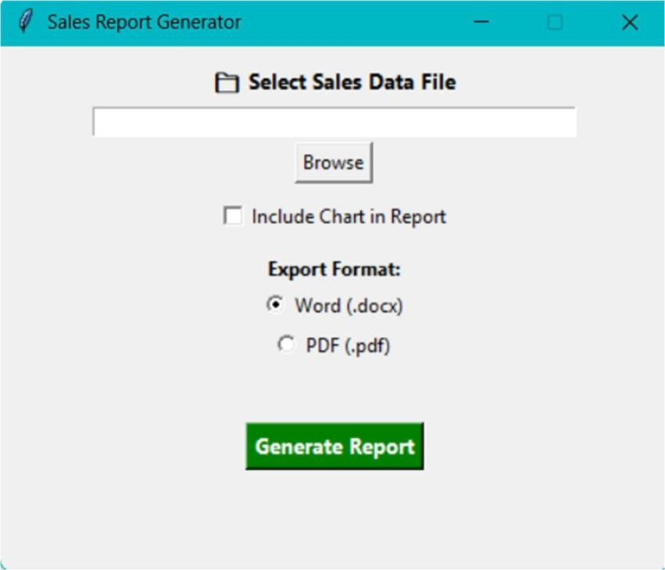

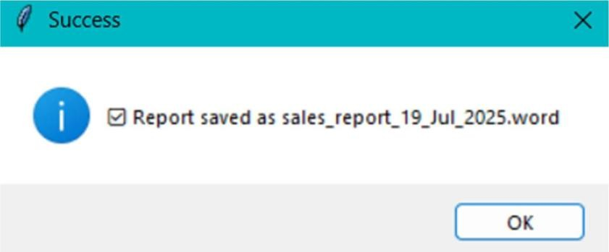
CHAPTER 6 CONCLUSION

6.1 Conclusion
The Sales Report Generator using Python GUI & MySQL successfully fulfills its objective of automating the sales reporting process, addressing the limitations of traditional manual reporting methods. Manual processes often include repetitive formatting, prone-to-error calculations, time-consuming chart creation, and the inability to maintain consistent report structures. By integrating modern open-source technologies such as pandas, python-docx, matplotlib, tkinter, reportlab, and MySQL, this system offers a robust, accurate, and efficient solution.
The application simplifies the workflow by allowing users to upload sales data in CSV or Excel format, automatically cleaning and mapping the data, and generating a fully formatted report in either Word or PDF format. The optional chart feature provides visual insight into product performance, enhancing decision-making and helping stakeholders interpret sales trends more rapidly. In addition, every processed record is stored in a MySQL database, enabling long-term data retention, audit support, and potential integration with future analytics dashboards or business intelligence tools.
From a usability perspective, the GUI was designed to be simple and intuitive, ensuring that even non-technical users can operate the system with minimal guidance. The auto-close feature, validation checks, and error messages improve user experience and system reliability. The modular programming approach further ensures that the system is easy to maintain, scalable, and extendable for future enhancements.
Overall, the project demonstrates how a combination of programming, data handling, visualization, and database techniques can result in a powerful real-world application. It highlights the impact of automation in reducing workload, improving accuracy, enhancing consistency, and promoting data-driven decision-making. The successful implementation and testing confirm that the system meets the requirements and objectives laid out during the project’s initial phase.

6.2 Future Enhancements
Although the system performs efficiently in its current version, there are several opportunities to extend its functionality, improve performance, and broaden its applicability. The following enhancements can be considered for future development:
1. Web-Based Deployment
The current desktop version can be expanded into a web-based application using frameworks like Flask or Django. This would allow multiple users to generate reports remotely using a browser without needing local installations.
2. Automatic Email Delivery
The system could be improved by implementing automated emailing of generated reports to managers or stakeholders. This feature would allow daily, weekly, or monthly scheduled reports to be auto-delivered.
3. Advanced Data Filtering
Adding filters such as date ranges, product categories, or location-based sales would increase flexibility and allow more customized reports.
4. Dashboard and Analytics
Integrating a real-time dashboard with charts, KPIs, and trend forecasting (possibly using Plotly, Power BI, or Grafana) can transform the system into a complete business intelligence tool.
5. Multi-User Authentication
User login and role-based access can ensure secure usage, allowing administrators, staff, and auditors to access only relevant features.
6. Support for More File Formats
Beyond CSV and Excel, future versions could support:
- JSON
- XML
- Google Sheets API
This would increase compatibility with a wider variety of data sources.
7. Mobile App Version
Using frameworks like Kivy or Flutter, a mobile version could be created, enabling report generation directly from smartphones.
8. Cloud Database Integration
Storing data in cloud-based databases such as AWS RDS or Firebase would enhance scalability and allow remote access from anywhere.
9. Enhanced PDF Styling
PDF generation could be further improved with:
- Complex table formatting
- Automatic page numbering
- Headers, footers, and watermarking
- Company logo embedding
10. AI-Based Insights
Integrating machine learning models could provide:
- Sales forecasting
- Anomaly detection
- Product performance prediction
These insights would add significant value for business decision-making.

6.3 Summary
The project’s development journey—from identifying the need, designing the solution, implementing modules, testing functionality, and refining user experience—demonstrates the power of automation in modern data workflows. The Sales Report Generator stands as a practical, efficient, and user-friendly system that significantly improves reporting efficiency and accuracy. With numerous possibilities for future expansion, the project lays a strong foundation for advanced reporting and analytics systems.

REFERENCES

- McKinney, W. (2017). Python for Data Analysis: Data Wrangling with Pandas, NumPy, and IPython. O’Reilly Media.
- Hunter, J. D. (2007). “Matplotlib: A 2D Graphics Environment.” Computing in Science & Engineering, 9(3), 90–95.
- Knight, D. (2022). Automating Office Tasks with Python. Packt Publishing.
- Mitchell, R. (2018). Python GUI Programming with Tkinter. Packt Publishing.
- Ramalho, L. (2015). Fluent Python: Clear, Concise, and Effective Programming. O’Reilly Media.
- Python Software Foundation. (2024). Python Documentation. Available at: https://docs.python.org/
- Pandas Development Team. (2024). Pandas Documentation. Available at: https://pandas.pydata.org/
- ReportLab Developers. (2024). ReportLab User Guide. Available at: https://www.reportlab.com/docs/
- MySQL Documentation Team. (2024). MySQL Reference Manual. Oracle Corporation. Available at: https://dev.mysql.com/doc/
- Goyal, A., & Sharma, P. (2023). “Automated Data Processing in SMEs Using Python.” International Journal of Computer Applications, 182(25), 12–19.
- IEEE Access. (2021). “Role of Database Integration in Business Tools.” IEEE Access, Vol. 9.
- SpringerLink. (2022). “Data Analysis and Visualization using Python.” Springer Publishing.
- MIT Open Research. (2023). “Automating Business Reports with Python.” Massachusetts Institute of Technology.
- TkDocs. (2024). Tkinter Reference Guide. Available at: https://tkdocs.com/
- Wixom, B. H., & Watson, H. J. (2010). “The BI-based Organization.” International Journal of Business Intelligence Research.

